**Procedure for Bouncing_Ball_Tracking_GUI.m**

The Bouncing_Ball_Tracking_GUI is a MATLAB interface that can be used to save the x- and y-pixel positions of a bouncing ball in addition to timestamps for the data from an .mp4 video file.

**Set-up Procedure:**

1. Convert video of your experiment to a MATLAB-readable format (i.e. MP4).

After transfering your video file from the camcorder to a computer, it must be converted from a .MTS file to a .MP4 video. This can be done with the free VLC media player available here: <http://www.videolan.org/vlc/index.html> . This software is also already installed on the ITLL computers. Follow this tutorial to see how to convert the file.

Open your file with VLC media player. This is done by clicking the Windows button, All apps, scrolling down to the letter “V” and selecting VideoLAN where the VLC media player should be. Then press Ctrl+R or go to Media🡪Convert/Save...

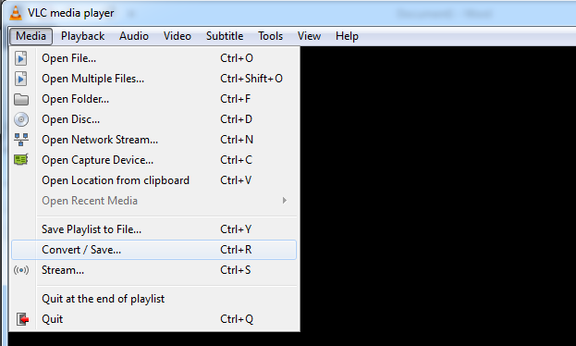

Next, add a video file you would like to convert and press Convert/Save…

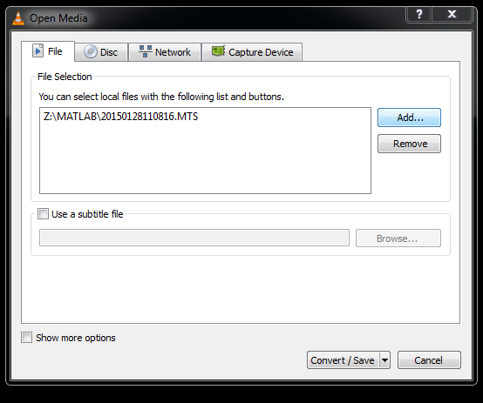

Then, select Video – H.264 + MP3 (MP4) for the convert profile, browse for where you want to save the file, and then press Start to convert the file…

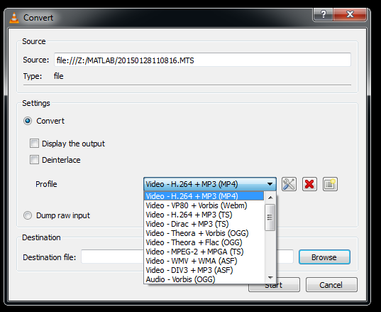

These steps must be repeated for each video file you would like to convert from .MTS to .MP4

1. Open the GUI by entering Bouncing_Ball_Tracking_GUI in the MATLAB command window. You will be prompted to select the file you wish to process.
2. The following message will pop up in the command window.



Wait until the message “Successfully loaded the file!” appears.

1. You should see the following GUI pop up:

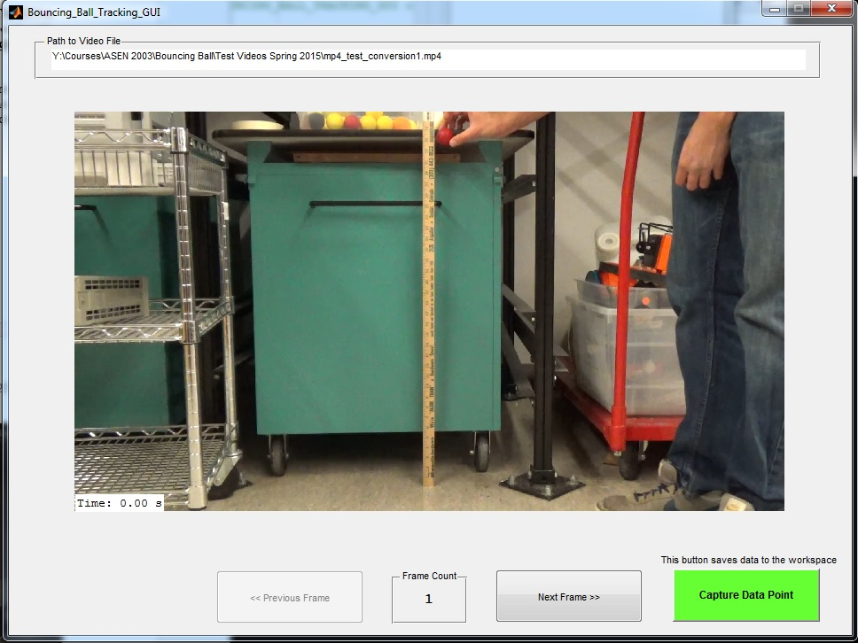

1. Click the Next Frame button until the ball begins to drop. Then go back a frame or two using the “Previous Frame” button. When you have found a good starting frame, click the “Capture Data Point” button. A set of crosshairs will appear in the GUI as shown below.

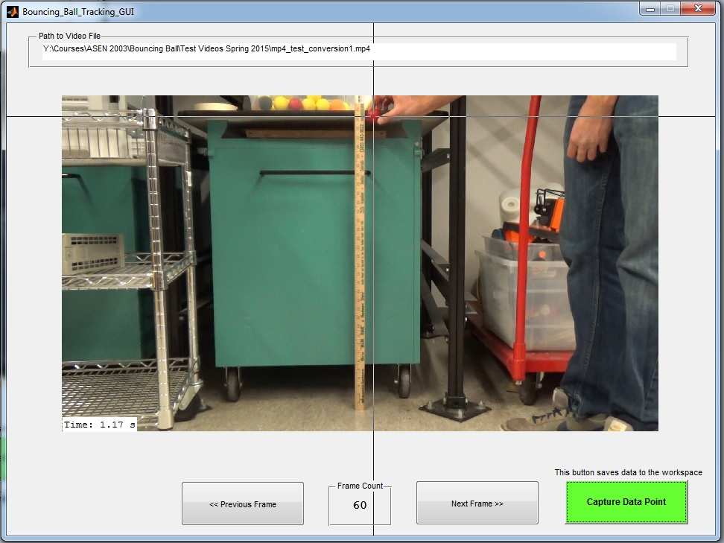

1. Using the crosshairs, click on the center of the ball. This will store the time, x position, and y position of the ball. Click the “Next Frame.” Capture data for all relevant frames in the video. Note that the ball may become blurry during the video. If this happens, try to click in the center of the blur. If you want to correct the data point you clicked, simply click the “Capture Data Point” button again and click the ball location to retake the data point. This will erase the old data point with the new one. If the ball goes out of the frame of view, click “Next Frame” until the ball is back in the view again.
2. When you get to the last frame in the video the “Next Frame” button will become greyed out. You can now close the GUI window.
3. The MATLAB workspace should now contain a data structure called ball_xy_position_data. This structure contains three arrays: time in seconds, x positon in pixels, and y position in pixels. A plot of some sample data is shown below.

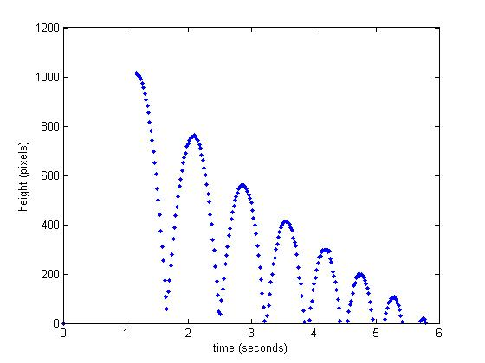

This plot was generated with the command: plot(ball_xy_position_data.time_seconds,ball_xy_position_data.y_pixel,'.')

1. Remember, if you want to use this data later, you must save it. The GUI does not save the data to anywhere but in the temporary storage of the MATLAB workspace. To save the data, right click the struct in the workspace and select “Save As.” Select a save location, file name, and select MAT-files (*.mat) for the Save as type.

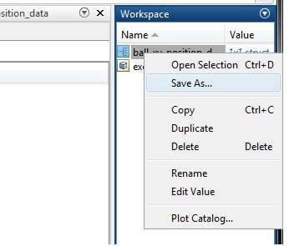

1. You can load the x- and y-positions of the ball (in pixels) by using the MATLAB ‘load(‘ function on the .mat file that was created.
2. You can convert height in pixels to height in meters by measuring the height of a known reference in the video. For example, if you know the height you dropped the ball from you can save this as a data point and then use the known height and pixel location to find the conversion from pixels to meters.